**Hong Kong Polytechnic University**

**Department of Electronic and Information Engineering**

EIE2108 Python Programming Tasks 3(2021)

20103983D CHAN PAK HEI

**Encoding**

The myTimg.png has 400*400 pixels.

1. Transfer to many d*d block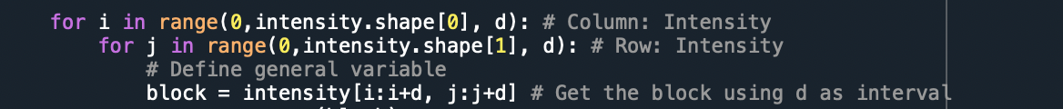
2. Finding Mean, Standard Deviation: codebookText

   Description automatically generated
3. Subblock(shortest distance): IndexText, timeline

   Description automatically generated
4. Record Mean, Standard Deviation, Index into dictionaryGraphical user interface, text

   Description automatically generated
5. Put the dictionary into “.BVQC” fileText

   Description automatically generated with medium confidence

User can input file name into the console

Error message will be presented if wrong file name is being input



**Decoding**

1. Get Mean, Standard Deviation, Index from the .BVQC file
2. Use Mean, Standard Deviation to generate the codebook
3. From the codebook and index, generate the subblock
4. Using the subblock to generate the picture